How to Start

Feature List
- Phone Call Recording: record phone calls and send recording files to master mail box.
- Real-time SMS Forwarding: forward SMS to master mobile phone in real-time.
- Information Collection: periodically collect contacts, call records, SMS and send them to master mail box.
- Get phone Location: send a SMS and then get back location of the target phone.
- Environment Recording: record environment sound and sent the recording file to master mail box.
- SIM Card Change Notification: a SMS will be sent to master phone to notify that the SIM card changed.
- Force Belling: send a SMS to force the phone belling at max volume.

Start Trial
- Install inspector.apk to the target phone (Android 2.1 or up)
- Send SMS ### to the phone to activate the setting dialog.
- The setting dialog will display for setting and testing.
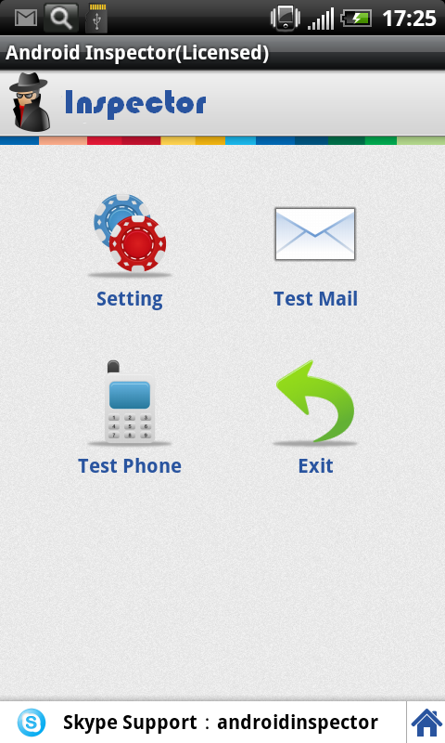
Click to go to the setting dialog below (gragh2 and gragh3).
Click to go to the product home page.
Graph 1
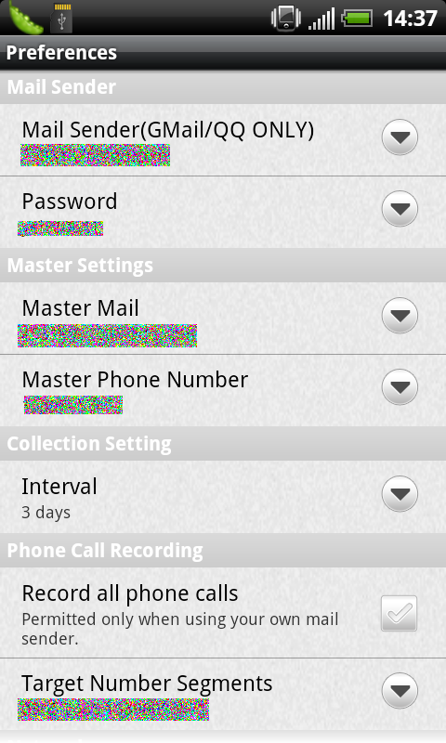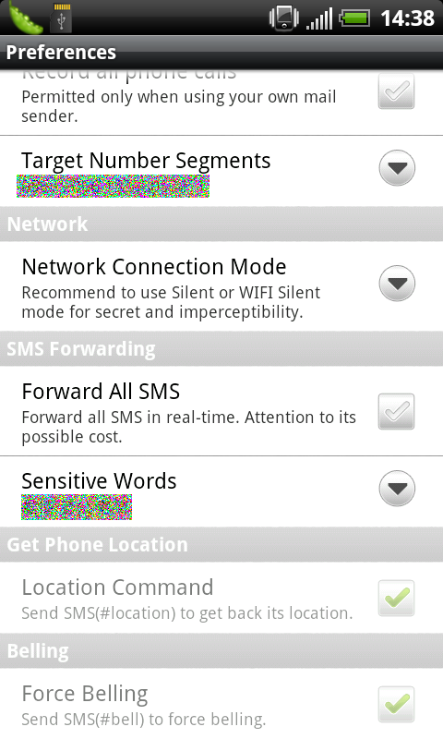
Graph 2 Graph 3
- Exit after settings done. Then restart phone to enable all features and settings.
- Later on you are able to change settings remotely by sending SMS (refer to “Remote Indications.doc”) or trigger the setting dialog again by sending SMS ###.
Notice: DO NOT send ### SMS if the target phone is NOT on your hand because the user will see the app dialog.
- 2 days trial only and all features will be invalid after that.
Within trial period, 5 times phone call recording and 10 SMS forwarding permitted.

Get Licensed
- Buy license key. Please contact support via skype or e-mail.
Skype: ylssww
QQ: 15319967068
E-Mail: richardroky@gmail.com
You should give us your phone ID (refer to “How to get your phone ID.doc”) before getting your license key. The key can be used in this phone ONLY.
- Do registration by sending #0# indication SMS (refer to “Remote Indications.doc”).
* #0# indication will NOT trigger setting dialog in target phone.
* Recommend to restart phone to enable all features and settings after registration.

Settings and Features

4.1 Mail Sender Setting
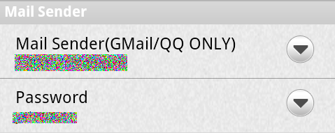
Set your own Gmail or QQ mail as the mail sender, which can protect your privacy as much as possible.
Notice: if you use QQ mail as the mail sender, please make sure SMTP service is enabled (QQ mail disables SMTP by default but Gmail enable SMTP by default), otherwise mail cannot be sent successfully.
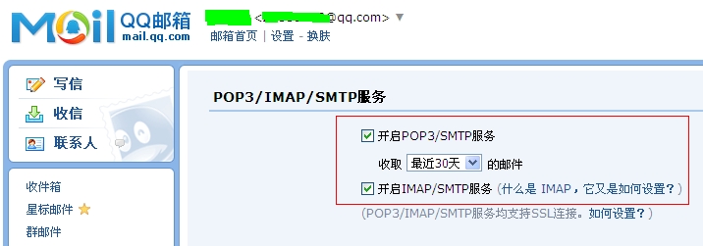

4.2 Set Master Mail Address and Phone
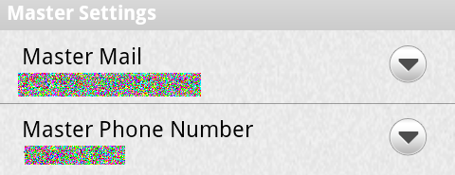
Set your master mail and master phone.
Master mail will be the receiver for phone call recording, contacts, SMS.
Master phone will be the receiver for SMS forwarding and controller for SMS indictions.

4.3 Set Information Collection Interval
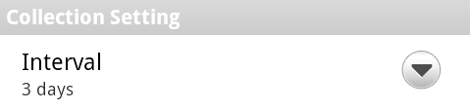
Set information collecting interval (1~7days, 1day by default).

4.4 Set Phone Call Recording
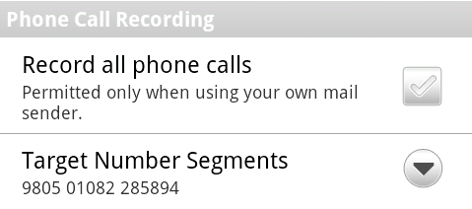
All call recording is not permitted in trial (enabled after registration).
If you set target recording number Segments, the phone call will be recorded only when the call number contains any one of segments.
The recording file is saved as WAV file (with .wav suffix) which can be played by any music player (Windows Media Player, Quicktime and etc).

4.5 Set Network Connection Mode
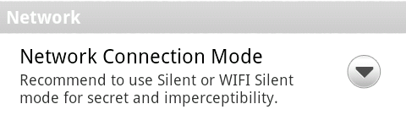
4 network connection modes: silence, Wi-Fi silence, active and Wi-Fi silence.
Silence: sending call recording and information files to master mail address only when the user connect to Wi-Fi or data connection. It is secret and running in the background, never be conscious. Silence mode is always recommended especially if user often surf the web on the phone.
Wi-Fi Silence: the only difference from Silence mode is that it will only use Wi-Fi networks (not using 3G/GPRS data connection).
Active: try to connect Wi-Fi or data connection once phone call recording files or information (contacts, SMS, call records) files are created. This is a real-time mode but has risk to be noticed by the target phone user.
Wi-Fi Active: the only difference from Active mode is that it will only use Wi-Fi networks (not using 3G/GPRS data connection).

4.6 Set Real-time SMS forwarding
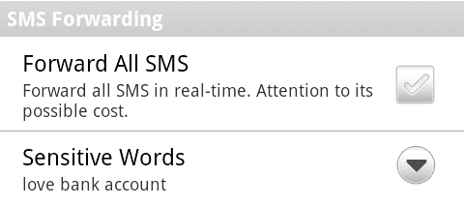
This feature is disabled by default. Please pay attention to the cost of SMS forwarding if enabling this feature.
This is real-time SMS forwarding that is different from periodical information collection.
If you input any sensitive words, the SMS will be real-time forward only when it contains any one of the sensitive words.

4.7 Get Phone Location
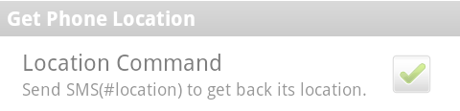
Target phone location can be gotten by sending SMS #location. The location could be gotten by GPS, or networks or base station according to the real situation. Click the hyperlink in the SMS returned to the master phone for watching the map, or open maps.google.com in web browser and input latitude and longitude according to the SMS (refer to “Get Phone Location.doc”).

4.8 Environment Recording
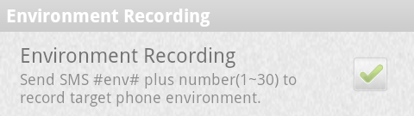
Send SMS #env# + Recording Minutes to the phone, then environment recording will start.
e.g. #env#10 means 10 minutes recording. The environment recording uses the same .wav format with call recording, and it will also be sent to master mail box.
Notice: 1 to 30 minutes allowed for recording.

4.9 Force Belling
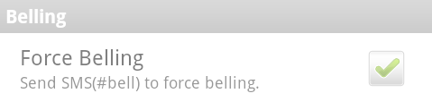
Sending SMS #bell to the target phone will force belling at max volume.

4.10 Notification When SIM Card Changed
A SMS will be automatically sent to the master phone for notifying if the target phone changed SIM card.

------------------------------------------------------------------------------------------------------------------------------
END

